Superstore Sales Analysis and Visualization Report

Name: Azmath Ur Rahman
Role: Data Analyst
Date : 12/13/2025

Introduction
The objective of this project is to analyze and communicate key business insights from the Global Superstore dataset using interactive Tableau visualizations. The analysis focuses on understanding sales, profit, customer behavior, discount impact, and regional performance across multiple dimensions. By leveraging well-designed visuals, this project aims to identify performance drivers, inefficiencies, and opportunities for improving sales and profitability.

Data and Visualization Overview
The Global Superstore dataset (2011–2015) was used to create a series of Tableau worksheets that collectively address sales performance, profitability, customer segmentation, discount effectiveness, and operational efficiency. Instead of relying on a single dashboard, individual visuals were designed to clearly answer specific analytical questions, aligning with best practices in data visualization.
The following visuals were created and analyzed:
- KPI – Total Sales
- KPI – Average Transaction Value
- KPI – Growth Rate (Month-over-Month)
- Time Series – Sales Trend
- Map – Sales by Region
- Category Performance
- Profit Analysis
- Discount Impact
- Customer Demographics
- Shipping Mode Performance

Key Findings

Regional and Store Performance
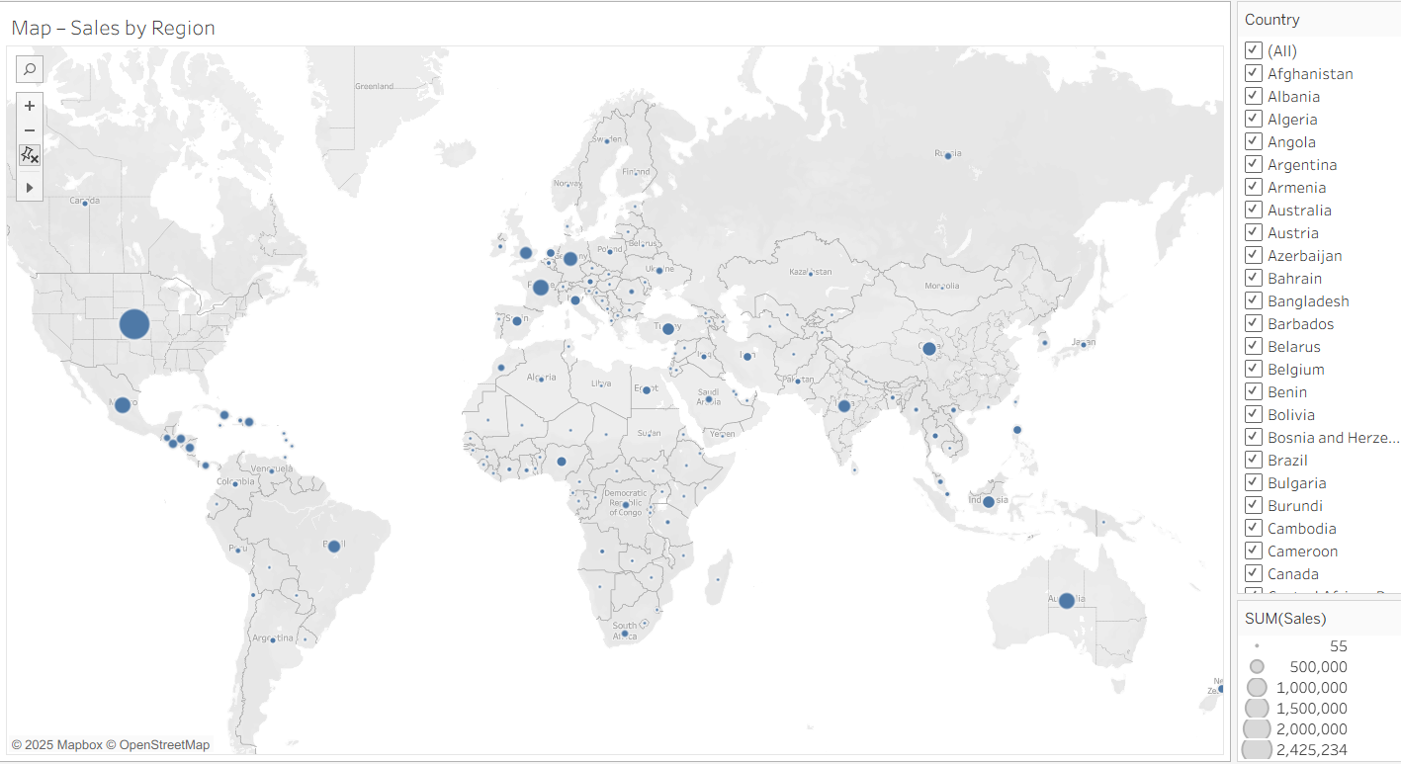
The Sales by Region map highlights that North America and parts of Europe generate the highest sales volumes, with the United States being the single largest contributor. Emerging markets such as parts of Asia and South America show moderate sales but represent potential growth opportunities. Certain regions consistently underperform, indicating possible issues related to logistics, market penetration, or demand.

Product Category and Profitability Insights
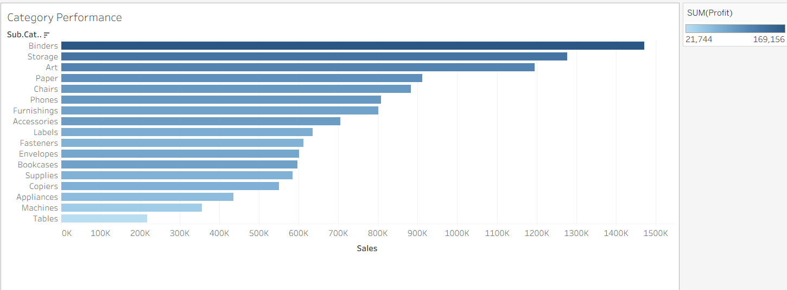

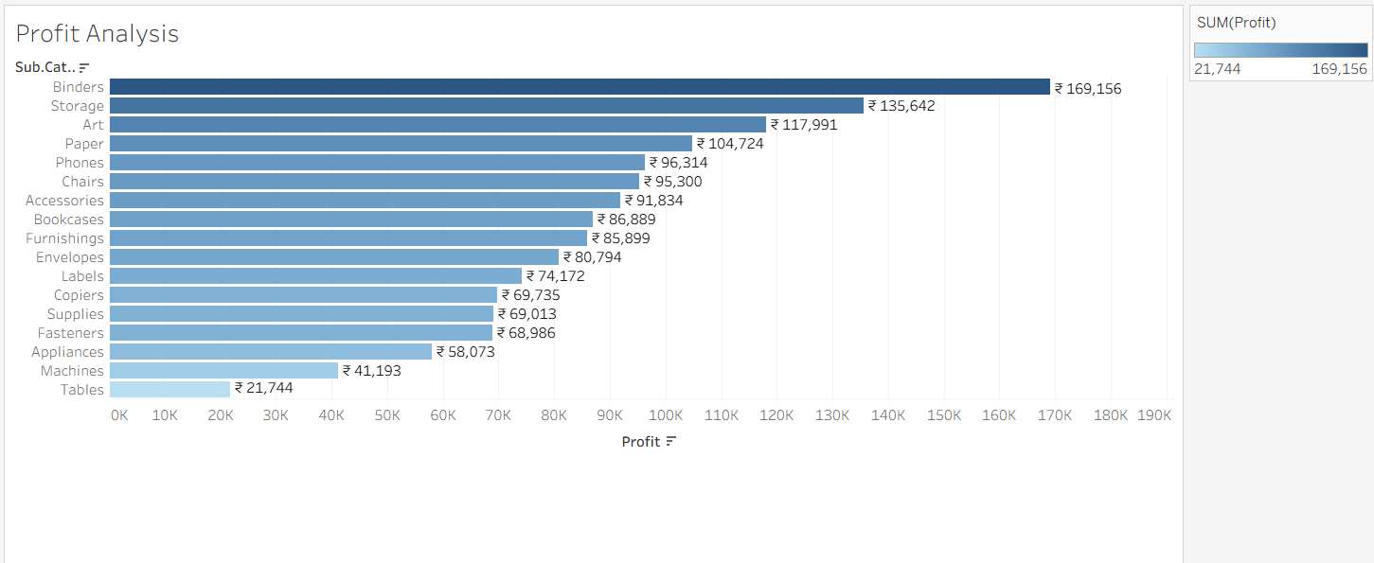
The Category Performance and Profit Analysis visuals reveal that not all high-revenue categories are equally profitable. Sub-categories such as Binders and Storage generate strong profits, while others like Tables and Machines show comparatively low profitability despite reasonable sales volumes. This suggests cost structure or discounting issues within specific product lines.

Trends Over Time
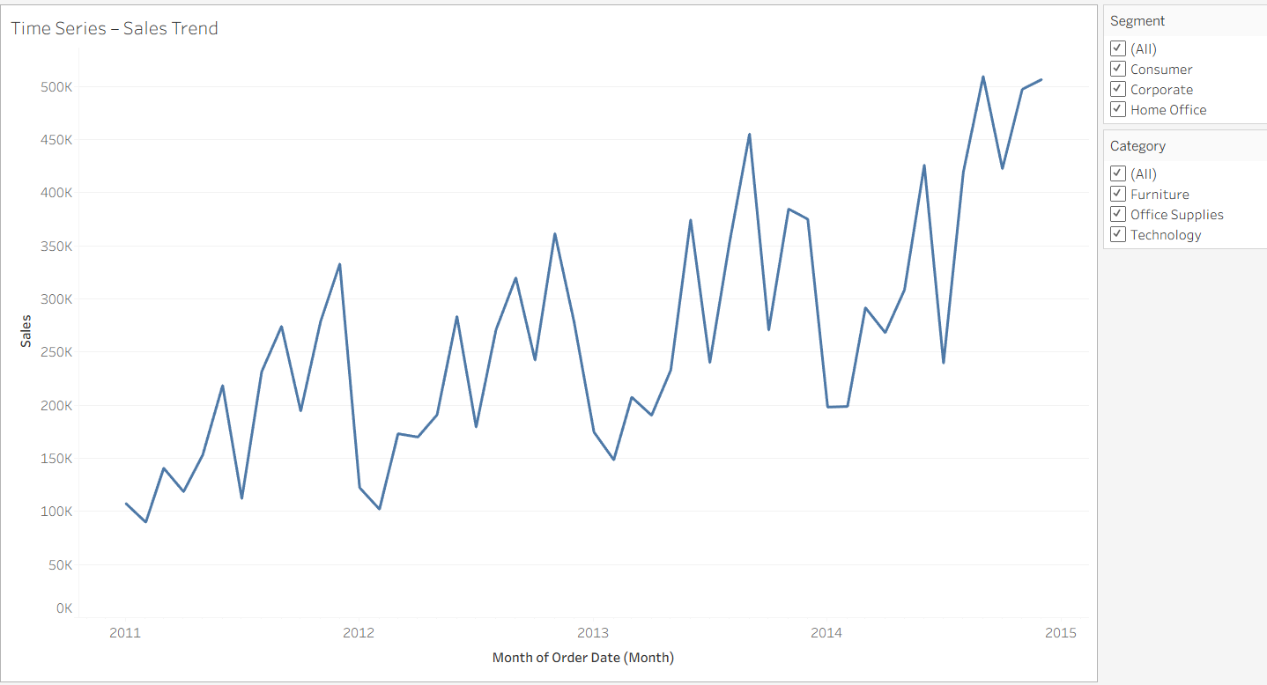
The Time Series – Sales Trend visualization shows an overall upward trend in sales from 2011 to 2015, with noticeable seasonal spikes, particularly toward year-end periods. These spikes likely correspond to promotional campaigns or increased holiday demand. The absence of prolonged downturns indicates stable long-term growth.

Discount Impact on Profitability
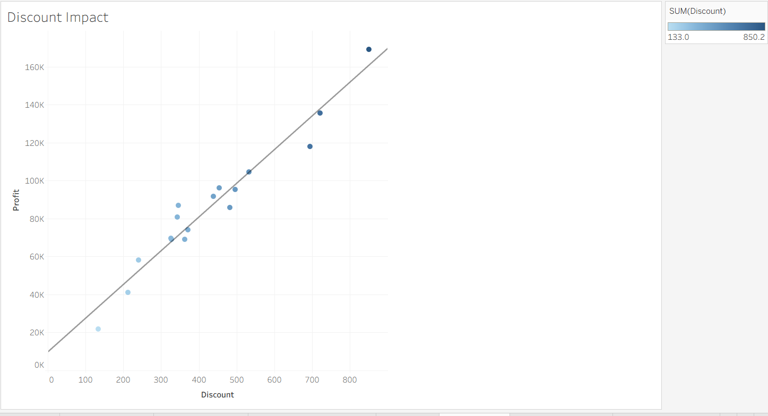
The Discount Impact scatter plot demonstrates a clear relationship between higher discount levels and profit variability. While moderate discounting can coincide with higher profits, excessive discounts often fail to proportionally increase profit and may even erode margins. This indicates that discount strategies are not consistently optimized across products or segments.

Customer Demographics and Segmentation
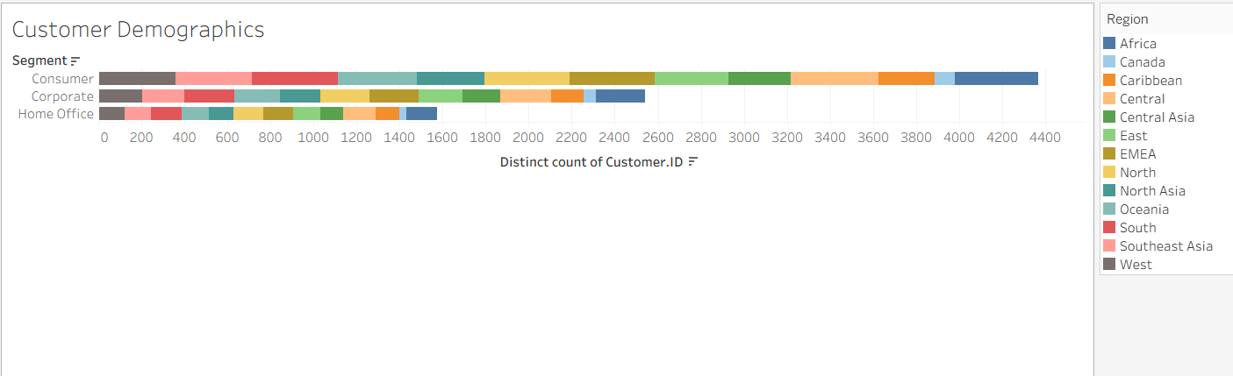
The Customer Demographics visualization shows that the Consumer segment accounts for the largest share of customers across most regions, followed by Corporate and Home Office. Regional color segmentation highlights that customer concentration varies significantly by geography, implying that marketing and sales strategies should be region- and segment-specific rather than uniform.

Shipping Mode Performance
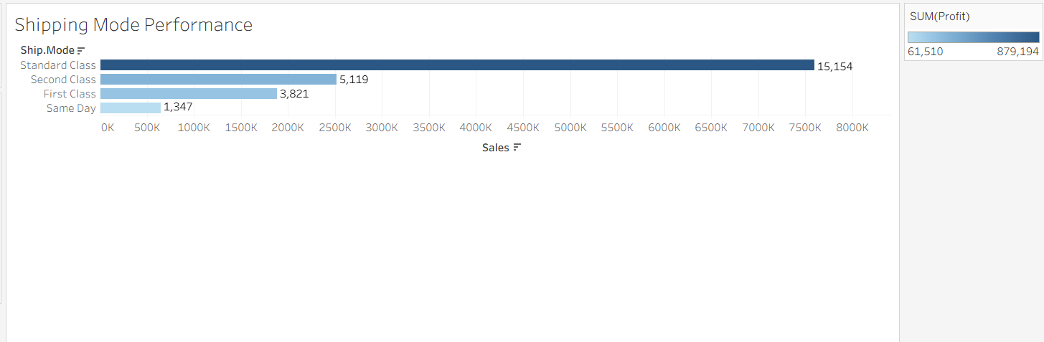
The Shipping Mode Performance analysis indicates that standard shipping dominates order volume, while faster shipping modes contribute less frequently but may impact customer satisfaction and cost. This suggests an opportunity to balance shipping cost efficiency with service-level expectations.

Data-Backed Insights (Summary)
- High sales volume does not always translate into high profit, particularly in certain sub-categories.
- Sales growth is steady over time with seasonal peaks, indicating predictable demand cycles.
- Aggressive discounting does not consistently improve profitability and may negatively impact margins.

Recommendations
Based on the analysis, the following recommendations are proposed:
- Optimize Product Portfolio: Re-evaluate low-profit sub-categories (e.g., Tables, Machines) to identify cost reductions, pricing adjustments, or discontinuation opportunities.
- Refine Discount Strategy: Implement data-driven discount thresholds to prevent excessive margin erosion while still driving volume.
- Region-Specific Strategies: Invest in targeted marketing and distribution strategies in underperforming but high-potential regions.
- Seasonal Planning: Align inventory and logistics planning with observed seasonal demand spikes to avoid stockouts and inefficiencies.
- Shipping Cost Management: Encourage cost-effective shipping modes while selectively offering premium shipping for high-value customers or orders.

Conclusion
This project demonstrates how Tableau can be used effectively to translate complex sales data into actionable business insights. Through focused visual analysis, key drivers of sales, profitability, and customer behavior were identified. The findings highlight the importance of balanced discounting, strategic product management, and region-specific decision-making. Future analysis could incorporate predictive modeling or customer lifetime value metrics to further enhance strategic planning.

References
Few, S. (2012). Show Me the Numbers: Designing Tables and Graphs to Enlighten. Analytics Press.
Tableau Software. (2023). Visual Best Practices. Tableau Knowledge Base.

